How to install angular in mvc5

Install

https://www.microsoft.com/en-us/download/details.aspx?id=48593 typescript for vs 2015

git clone https://github.com/angular/quickstart

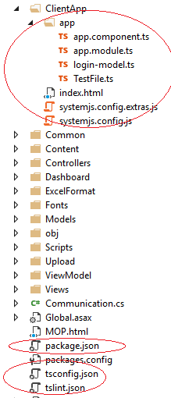

Next we'll edit tsconfig.json, from this:

{

"compilerOptions": {

"diagnostics": true,

"emitDecoratorMetadata": true,

"experimentalDecorators": true,

"lib": [ "es2015", "dom" ],

"listFiles": true,

"module": "commonjs",

"moduleResolution": "node",

"noImplicitAny": true,

"outDir": "wwwroot",

"removeComments": false,

"rootDir": "wwwroot",

"sourceMap": true,

"suppressImplicitAnyIndexErrors": true,

"target": "es5"

},

"exclude": [

"node_modules"

]

}

**npm install ---- for node isntallation**